**CYP-AMWU QUERY USER MANUAL**

**Rate Update/Add**

**1.1 Rate Update**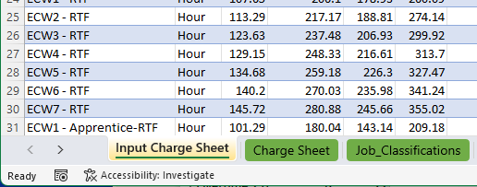

**Solution:**

1.Click and work on “Input Charge Sheet” to add or update new rates.

2.Click “Refresh” to update the latest rate information on “Charge Sheet” and “Daily Cost Detail” Worksheet.

**1.2 New Rate from New Cost Centre**

**Solution:**

1.Input the new rate at the bottom of “Input Charge Sheet” worksheet

2.Format Job Classification column as following format:

“Job Level” – “Cost Centre Acronym” e.g., TW3 - XXX

**1.3 New Cost Centre Worksheet Add**

**Solution:**

1. 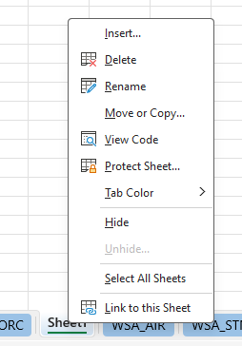Insert a new worksheet rename it as “New Cost Centre”.
2. Click “Data”-> Get Data -> From Other Sources -> Blank Query

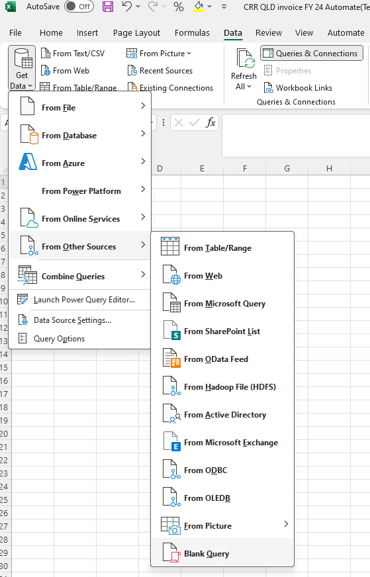

3.Paste Following Code in the blank.

= Excel.CurrentWorkbook(){[Name="Daily_Cost_Detail___Actual"]}[Content]

And name this Query by Cost-Centre. For example: HBM Invoice

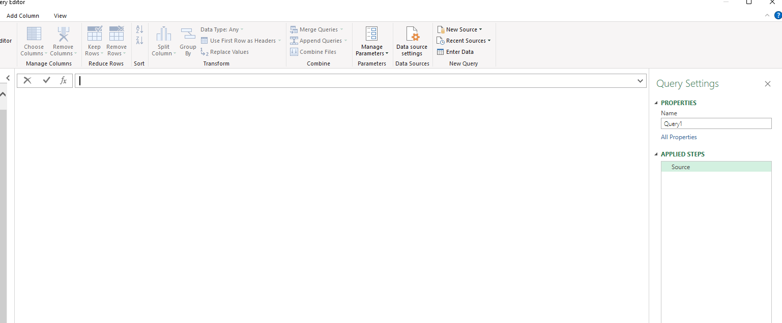

1. Filter out the irrelevant data by deselecting irrelevant option within **“Location”.**

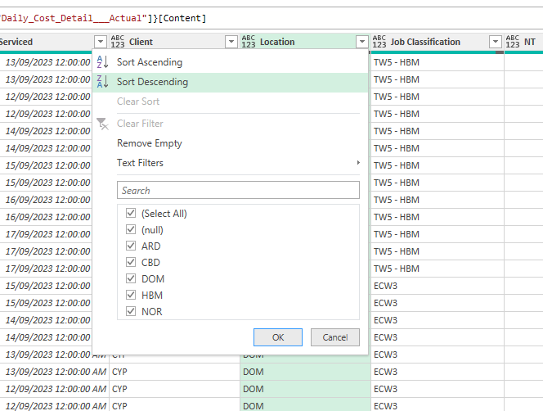

**5**. Change “serviced” column data type to **“Date”**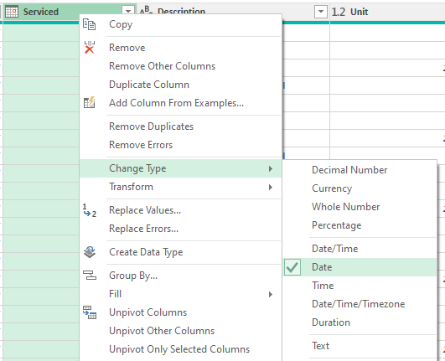

**6.** Close the window and save changes.

**Rate Missing**

**1.Rate doesn’t come through on “Daily Cost Detail_-_Actual” Work sheet**

**Solution:**

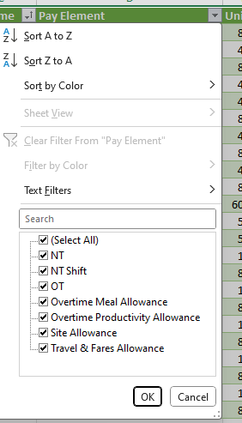1.Check **“Daily Cost Detail_-_Actual”** worksheet,

**“Pay Element”** Columns.

If there are options different from the following:

“NT”

“NT Shift”

“OT”

“Overtime Meal Allowance”

“Overtime Productivity Allowance”

“Site Allowance”

“Travel & Fares Allowance”

**2.Click Data -> Queries & Connections -> Daily_Cost_Detail_-_Actual,**

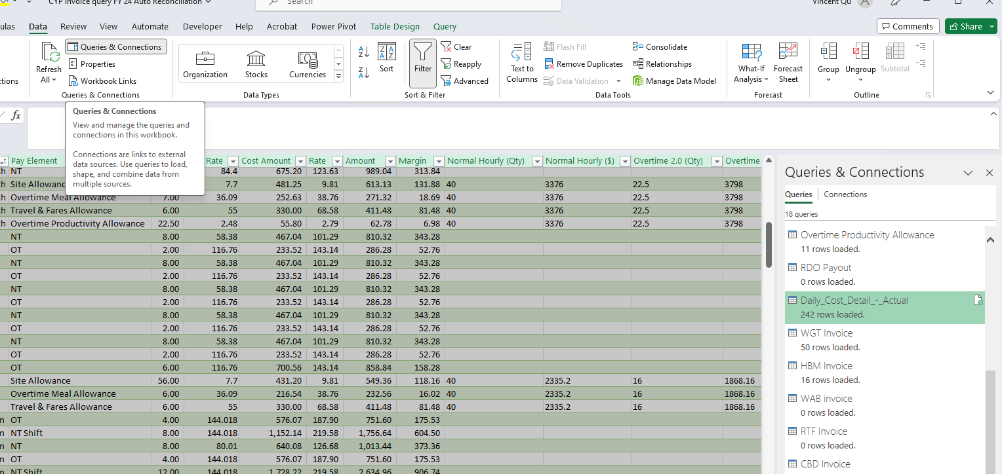

**3.Click on Replaced Value 18 -> Right Click “Pay Element” -> “Replace Values”**

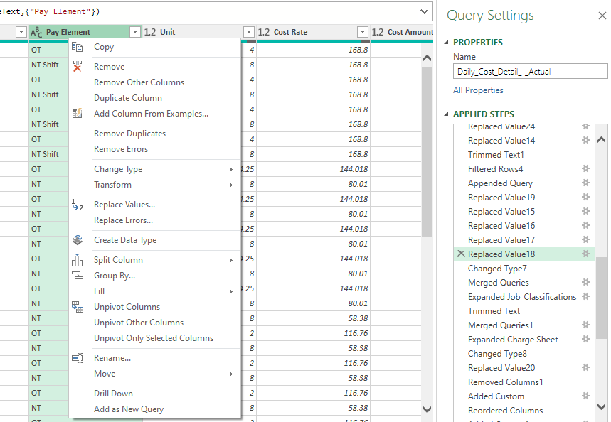

**4.Click Insert**

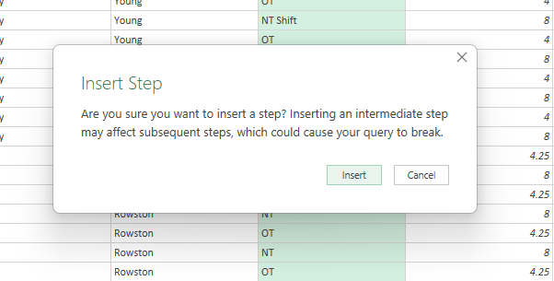

**5.Replace Values**

Values To Find:

The Value **differentiate** from following Description:

“NT”

“NT Shift”

“OT”

“Overtime Meal Allowance”

“Overtime Productivity Allowance”

“Site Allowance”

“Travel & Fares Allowance”

Replace With:

One of Following:

“NT”

“NT Shift”

“OT”

“Overtime Meal Allowance”

“Overtime Productivity Allowance”

“Site Allowance”

“Travel & Fares Allowance”

**e.g., Replace "Overtime Productivity Allowance-VIC" With**

**"Overtime Productivity Allowance"**

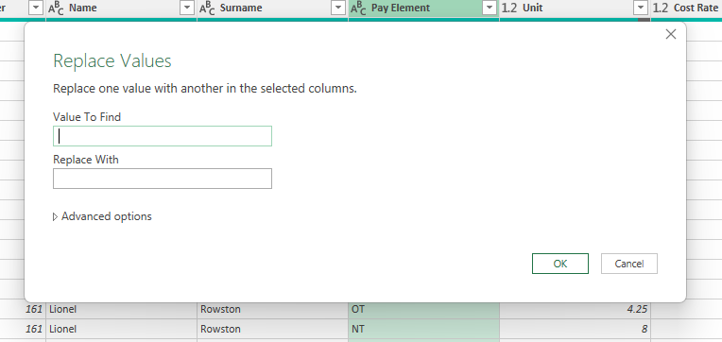

1. **Save and close the Query window.**